# Exercise: Playwright

You are given a **Web application** using JavaScript. The application dynamically displays content, based on user interaction and supports user profiles and CRUD operations, using a REST service.

Open the **Resources** folder – inside is the **Library_Catalog** folder, which contains the necessary files.

## 1. Preparing the Environment

To initialize the application, execute the following commands in the Visual Studio Code terminal:

|  |
| --- |
| **npm install** |

This will install the **Playwright** framework and other required packages.

Then, start the server by using the following command:

|  |
| --- |
| **npm run start** |

Then open another CLI and type this command:

|  |
| --- |
| **npm run server** |

Navigate to <http://localhost:3000/> to start using the application.

After that, create a new folder, named "**tests**" and in it, create a new file, named "**ui.test.js**". This file will contain the UI tests that we'll write using **Playwright**.

**NOTE:** To execute the command for running the Playwright tests, just open a new terminal in Visual Studio code and write the following:

|  |
| --- |
| **npm test** |

## 2. Application Specifications

### Navigation Bar

**Guests** (un-authenticated visitors) can see the links to the **All Books,** as well as the links to the **Login** and **Register** pages. The logged-in user navbar contains the links to **All Books** page, **My Books** page, the **Add Book** page, **Welcome, {user's email address}**, and a link for the **Logout** action.

**User** navigation example:

**Guest** navigation example:

### Login User

|  |
| --- |
| The included REST service comes with the following premade user accounts, which you may use for development:  **{ "email": "peter@abv.bg", "password": "123456" }**  **{ "email": "john@abv.bg", "password": "123456" }** |

The **Login** page contains a form for existing user authentication. By providing an **email and password** the app logins a user in the system, if there are no empty fields.

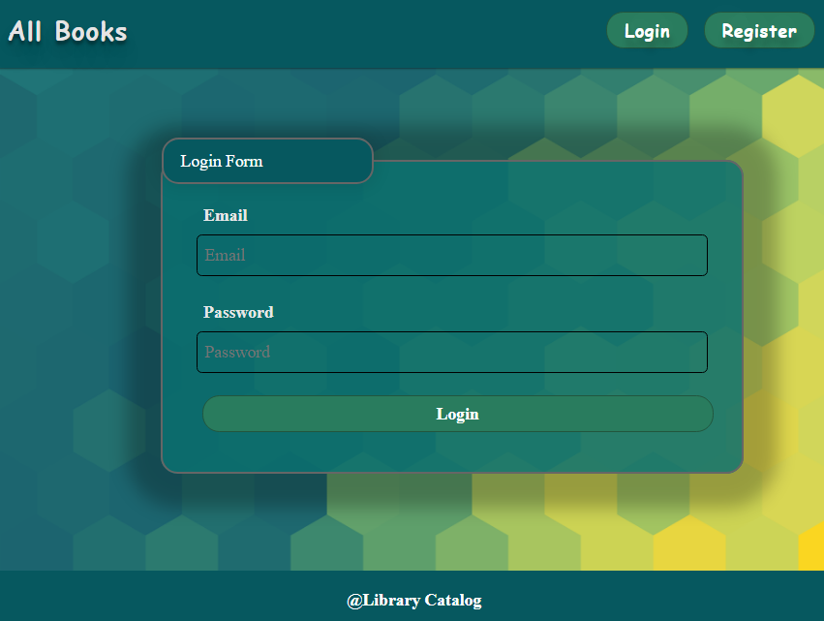

If the login is successful, the app **redirects** the user to the **All Books/Dashboard** page. If there is an error, or the **validations** don't pass, it displays an error message, using a system dialog (window.alert).

### Register User

By given **email and** **password**,the app registers a new user in the system. All fields are required – if any of them is empty, the app displays an error.

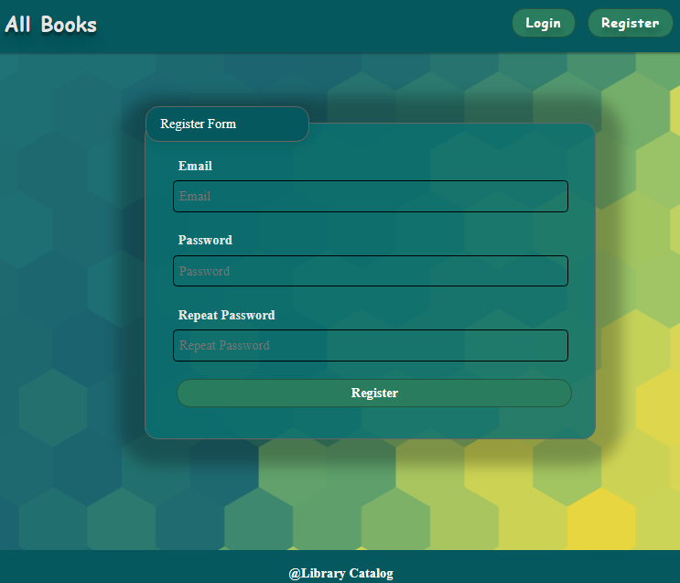

If the registration is successful, the app **redirects** the user to the **All Books/Dashboard** page. If there is an error, or the **validations** don't pass, it displays an error message, using a system dialog (window.alert).

### Logout

The logout action is available to **logged-in users.** If the logout is successful, the app **redirects** the user to the **All Books/Dashboard** page.

### Add Book

The **Add Book** page is available to **logged-in users**. It contains a form for adding a new book. Checks if all the fields are filled before you send the request.

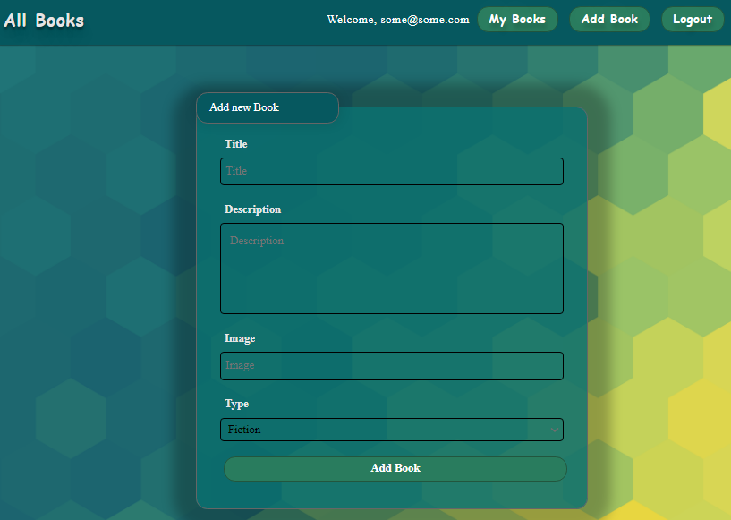

Upon success, it **redirects** the user to the **All Books/Dashboard** page.

### All Books

This page **displays** a list of **all books** in the system. Clicking on the details button in the cards leads to the details page for the selected book. This page should be visible to **guests and logged-in users**.

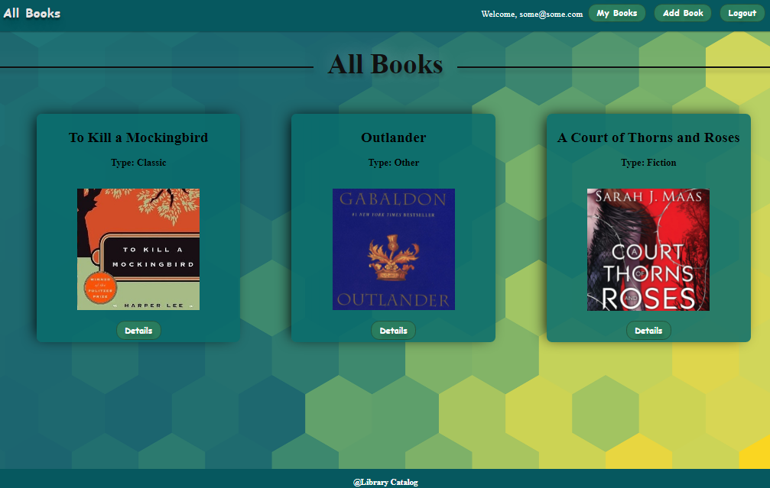

If there are **no books**, the following view is displayed:

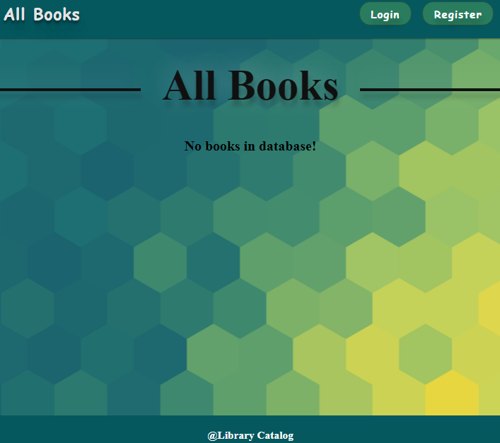

### Book Details

**All users** are able to **view details** aboutbooks. Clicking the **Details** link in of a **book card** **displays** the **Details** page. If the currently **logged-in user** is the **creator**, the [Edit**]** and [Delete**]** buttonsare displayed, otherwise they are not available.

The **view** **for** the **creators** looks like this:

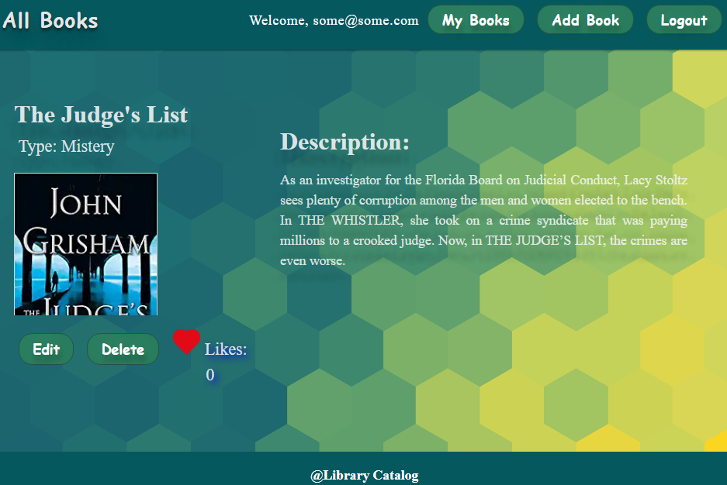

The **view** **for** the **non-creators** looks like this:

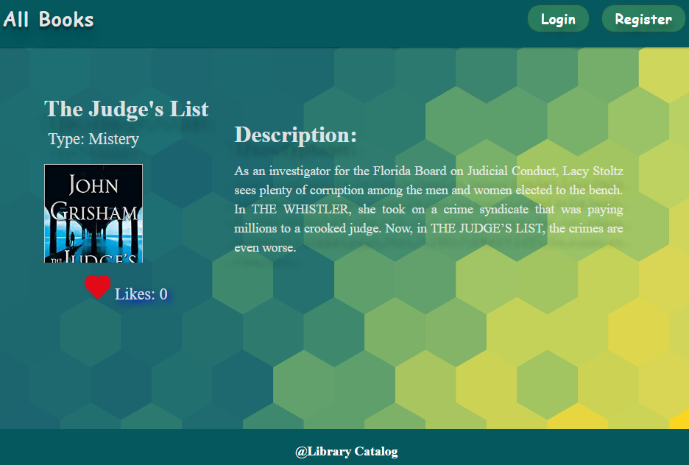

### Edit Book

The **Edit** page is **available to logged-in users** and it allows **authors** to **edit** their **own** book. Clicking the **Edit** link of a particular book on the **Details** page displays the **Edit** page, with all fields filled with the data for the book. It contains a form with input fields for all relevant properties. Checks if all the fields are filled before you send the request.

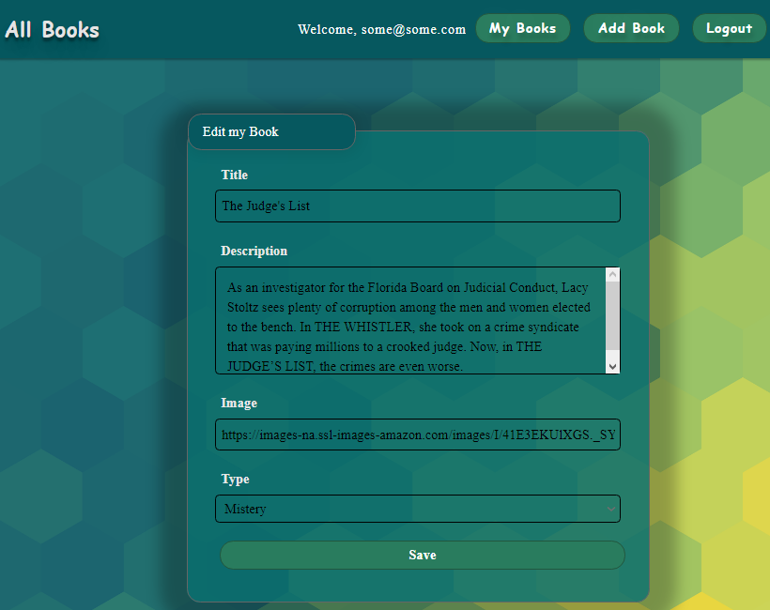

### Delete Book

The delete action is available to **logged-in users**, **for books they have created**. When the author clicks on the **Delete** action on any of their book, a confirmation dialog is displayed, and upon confirming this dialog, the book is **deleted** from the system and the user is **redirect** to the **All Books/Dashboard** page.

### My Books

Each **logged-in** **user is** able to **view their own books** by clicking **[My Books]**. Here are listed all books added by the current user.

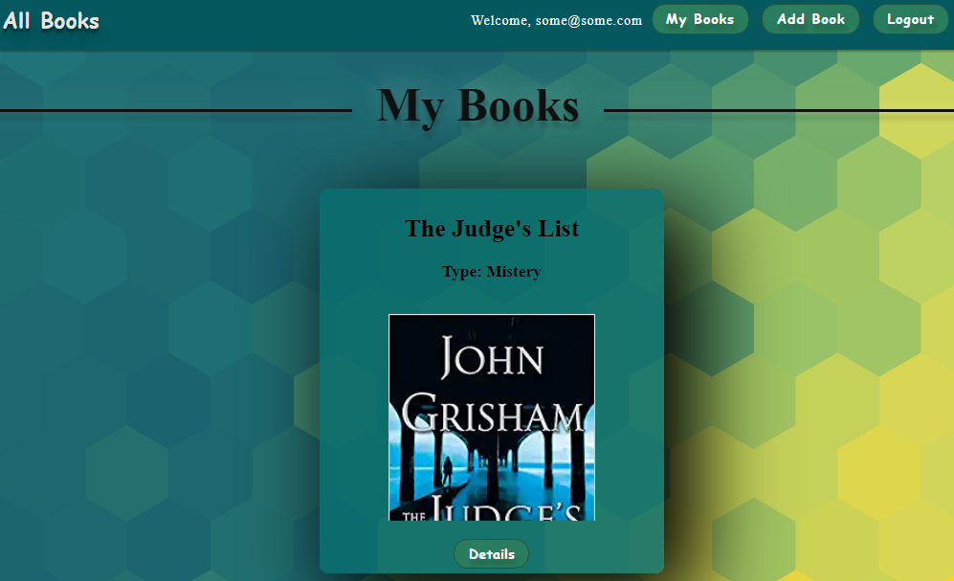

If there are **no books**, the following view is displayed:

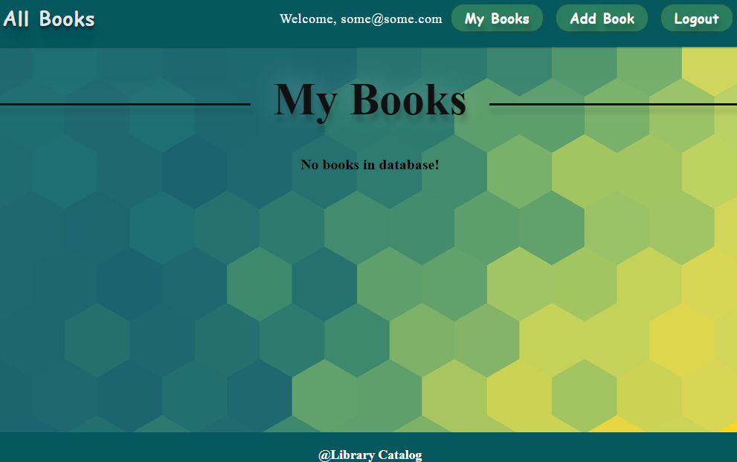

### Like a Book

Every **logged-in user** is able to **like other books**, but **not his own**. By clicking on the **[Like]** button, **the counter of each book increases by 1**.

The view when the user did not press **[Like]** button looks like:

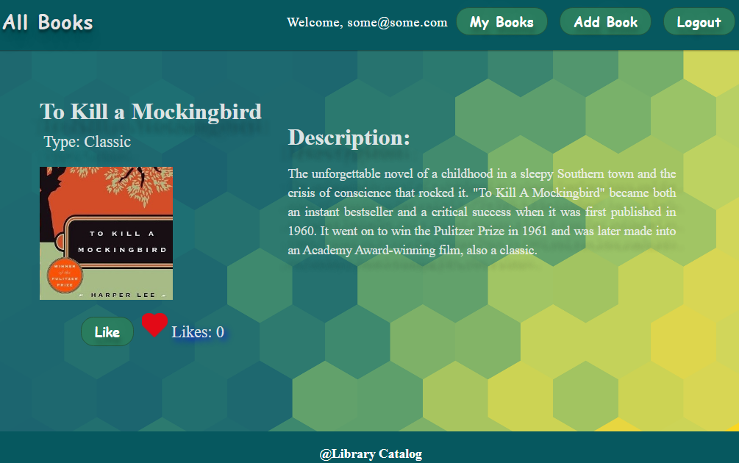

When the user **liked** the book, the **[Like]** button is **not** available and the counter is **increased** by **1**.

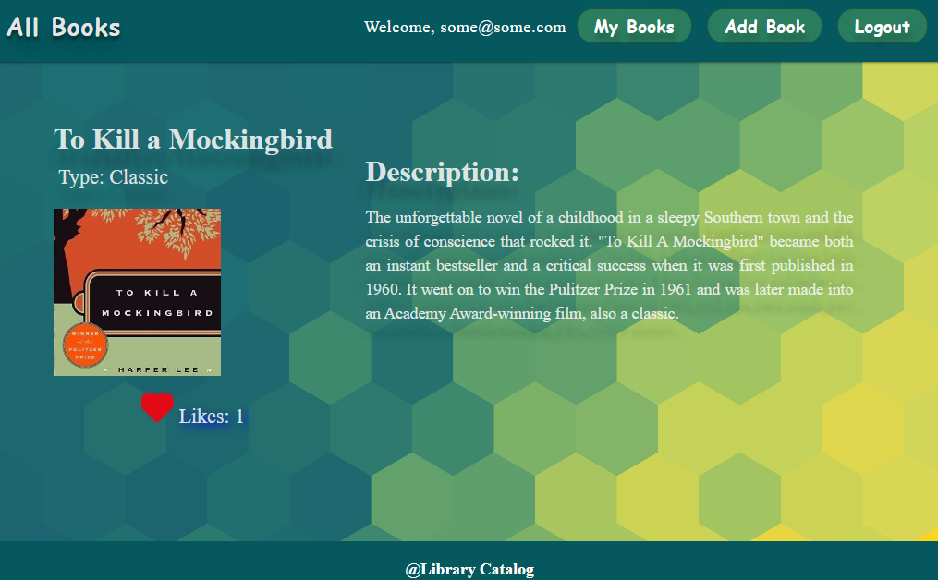

**Creator** is not able to see the **[Like]** button. The view looks like:

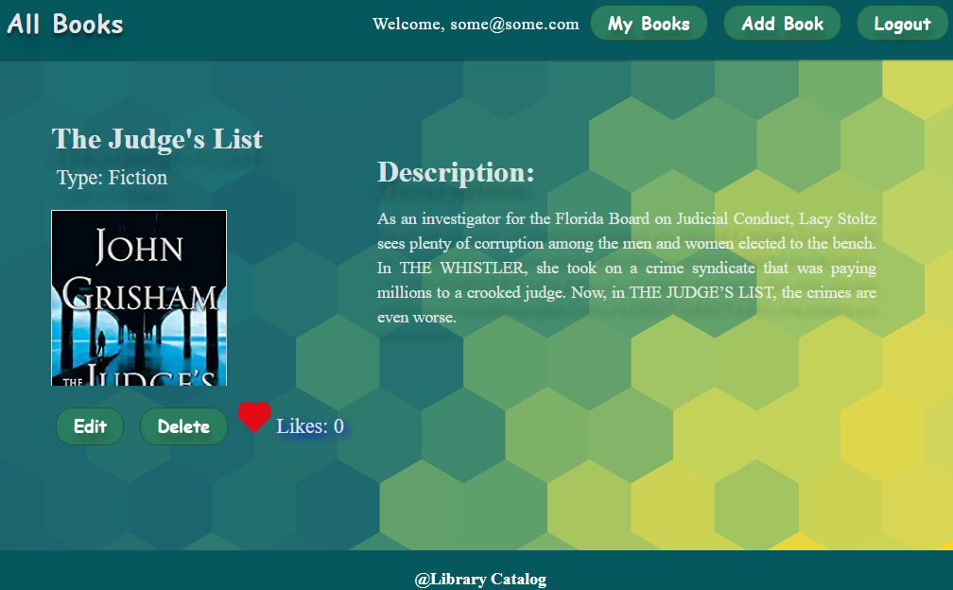

**Guest** are not able to see the **[Like]** button. The view for **guests** looks like:

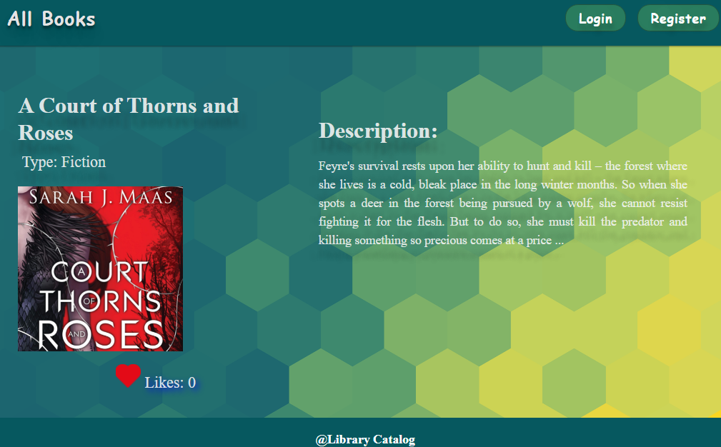

## 3. Write Web UI Tests

Your task is to write Web UI tests, using Playwright, in order to test the UI of the given app.

### Navigation Bar for Guest Users

Let's write test for the navigation bar that should be displayed for guest users. The tests are listed below.

#### Verify That the "All Books" Link Is Visible

We have to verify that the "**All Books**" link is visible. To do that, we have to import the **test** and **expect** functions from the **@playwright/test** package. These functions are used for defining tests and making assertions within the tests:



Then, we have to define a test case using the **test** function. The test case is named "**Verify 'All Books' link is visible**". It is an asynchronous function that takes an object destructuring argument with **page** as one of the properties. **page** represents the browser page that will be used for the test:



After that, we have to navigate to the **page** to the specified URL, which is **http://localhost:3000**. It opens the web application in the browser:



We have to wait for the navigation bar to load on the web page. Playwright waits until an element matching the CSS selector **nav.navbar** becomes visible on the page:



Then, we have to find the element representing the "**All Books**" link on the page. We use the **$** function of the **page** object along with the CSS selector '**a[href="/catalog"]**' to select the link element:



Then, we check whether the "**All Books**" link is visible on the page. We use the **isVisible** function on the **allBooksLink** element to determine its visibility:



Finally, we make an assertion using the **expect** function. It expects the value of **isLinkVisible** to be **true**. If the value is not **true**, the test will fail:



#### Verify That the "Login" Button Is Visible

First, let's define a test case titled "Verify 'Login' button is visible":



Then, navigate to the specified URL that holds the html element we want to test:



After that, wait for the **nav.navbar** selector to appear on the page and ensure that the navigation bar has loaded before proceeding with the test:



Then, we use the **$** function on the page to select the **[Login]** button, based on its selector (**a[href="/login"]**):



After that, we use the **isVisible** function to check if the **[Login]** button is visible in the browser. Let's not forget that the **isVisible** function returns a boolean value indicating the visibility of the element:



Finally, use the **expect** function to assert that the **[Login]** button is visible. If the expectations are not met, the test will fail:



#### Verify That the "Register" Button Is Visible

Try and write a test by yourself which verifies that the **[Register]** button is visible. The test should be similar to the one verifying the visibility of the **[Login]** button.

### Navigation Bar for Logged-In Users

Now let's write some tests for the navigation bar that should be displayed for logged-in users. The tests are listed below.

#### Verify That the "All Books" Link Is Visible

To verify that the "**All Books**" links is visible after login, we should first define the test case:



As we are testing the visibility of links in the navigation bar that is displayed to a logged-in user, we should first navigate to the login URL [**http://localhost:3000/login**](http://localhost:3000/login), so that we login:



Then, we fill the input fields with the predefined credentials and click on the **[Submit]** button. This way Playwright submits the form with the filled in credentials:

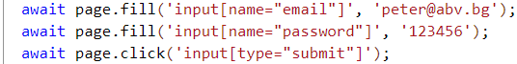

After that, we retrieve the element, that represents the "**All Books**" link using a selector and check its visibility, using the **isVisibile()** function:



Finally, we use the **expect** assertion to compare the visibility of the "**All Books**" link with the expected value **true**:



#### Verify That the "My Books" Link Is Visible

Try and write a test by yourself which verifies that the "My Books" button is visible after user login. The test should be similar to the one verifying the "**All Books**" link.

#### Verify That the "Add Book" Link Is Visible

Try and write a test by yourself which verifies that the "**Add Book**" button is visible after user login. The test should be similar to the one verifying the "**All Books**" link.

#### Verify That the User's Email Address Is Visible

Try and write a test by yourself which verifies that the user's email address is visible. The test should be similar to the one verifying the "**All Books**" link.

### Login Page

Now, let's test the login page. The tests are listed below.

#### Submit the Form with Valid Credentials

Let's write a test that fills the form with valid credentials and submits the form.

We already know how to define the test case and navigate to the login page. After that, we should start filling in the input fields with the predefined credentials, described in the beginning of this document:

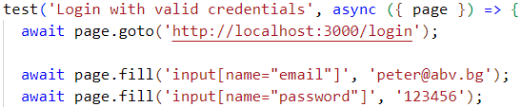

After we're ready with filling the form, we click on the **[Submit]** button in order to submit the form:



Finally, we should check if we have been directed to the correct page:

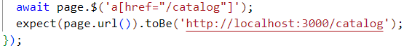

#### Submit the Form with Empty Input Fields

Now, let's write a test that submits an empty form.

First, define the test case. Then, as in the previous tests, we should first navigate to the login URL and click on the **[Login]** button:



Then, we should listen for the **dialog** event, which would visualize an alert popup window with the warning message. After that we, should verify that the dialog type is indeed **alert** and check if the message is the same as in the **login.js** file. Finally, we should click on the **[OK]** button in order to dismiss the alert window:

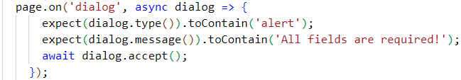

We should also check whether we have been redirected to the right page or not:



#### Submit the Form with Empty Email Input Field

Try and write a test by yourself which submits the form with an **empty** **email** field and a **valid password** field.

#### Submit the Form with Empty Password Input Field

Try and write a test by yourself which submits the form with a **valid email** field and an **empty password field**.

### Register Page

Try writing some test by yourself for the "**Register"** page. They should be similar to the tests regarding the **Login** form. The tests are described below.

#### Submit the Form with Valid Values

Write a test that submits the form with **valid values for the email and the passwords**. Check if you're redirected to the correct page.

#### Submit the Form with Empty Values

Write a test that submits the form with **empty input fields for the email and the passwords**. Check if the alert message is the correct and whether you have been redirected or not.

#### Submit the Form with Empty Email

Write a test that submits the form with **an empty email input field and valid password input fields.** Check if an alert appears and if it has the expected text message.

#### Submit the Form with Empty Password

Write a test that submits the form with **an empty password input field and valid email input fields.** Check if a popup alert appears and if it has the expected text message.

#### Submit the Form with Empty Confirm Password

Write a test that submits the form with **an empty confirm password input field and valid email input field and valid password input field**. Check if a popup alert appears and if it has the expected text message.

#### Submit the Form with Different Passwords

Write a test that submits the form with **valid email, but different passwords in the two password input fields**. Check if a popup alert appears and if it has the expected text message.

### "Add Book" Page

Now let's test the "**Add Book**" page.

#### Submit the Form with Correct Data

Let's write a test that submits the form for adding a book with correct data.

First, we have to go to the "**Login**" page and fill in the predefined email and password credentials and click on the **[Submit]** button in order to be logged-in, as only logged-in users can add books:

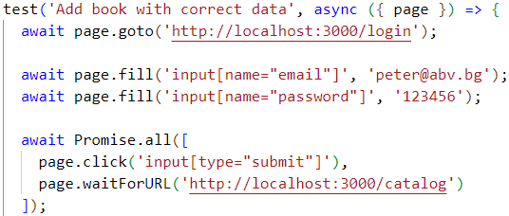

As you can see from the code above, we also wait for the navigation to the "**Catalog**" page, as all users should be redirected to that page after login.

Then, we have to go to the "**Add Book"** page via the navigation menu link:



We then wait for the form to load:



After the form has been loaded, we start filling in the book details with some dummy data:

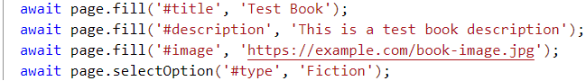

Keep in mind that the Type field is a dropdown menu and you should input only the predefined types – "**Fiction**", "**Romance**", "**Mistery**", "**Classic**" or "**Other**".

After we are finished with filling in the book information, we click on the **[Submit]** button:



Finally, we verify that we're being redirected to the correct page – this is our indicator that the book has been successfully added:

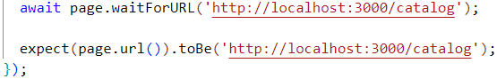

#### Submit the Form with Empty Title Field

Now let's write a test that verifies the app behavior when we send the form with an empty title field.

We should again first navigate to the Login page, then login with the predefined credentials and go to the **"Add Book"** page:

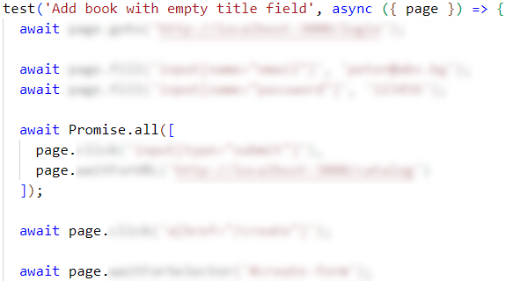

We start filling the book details, but we leave the title field empty:

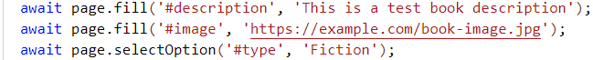

This time, we have to check if an alert popup window appears, that has the " **All fields are required!**" text message. We already know how to do that:

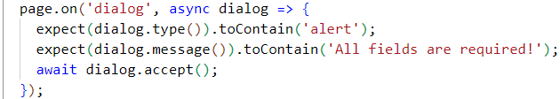

Finally, we check if we're redirected to some other page or if we're navigated to the "**Add Book**" page:

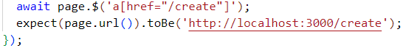

#### Submit the Form with Empty Description Field

Write a similar test, but this time leave the **description** field empty.

#### Submit the Form with Empty Image URL Field

Write a similar test, but this time leave the **image URL** field empty.

### "All Books" Page

Now let's write some tests for the "**All Books**" Page.

#### Verify That All Books Are Displayed

Let's first verify that all added books are being displayed. Of course, we have to first login with one of the predefined users and then navigate to the "**All Books**" page:

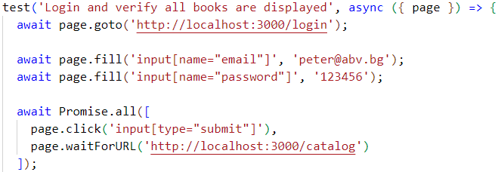

In order to get the book list, we have to wait for it to load and get it via the CSS class that is assigned to it:



We then get all of the book elements and verify that they are displayed by checking whether their count is greater than 0:

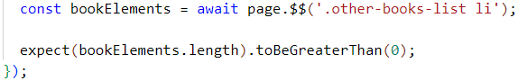

#### Verify That No Books Are Displayed

Now, let's write a test that verifies that when there are no books in the database, a message that says "**No books in database!**" is displayed.

First, delete all books – you can do that manually. Then, we'll use the code from the previous test and adjust to check if there is a message with **no-books** class that says "**No Books in the Database!**":



Note that if you delete all books, you should either start the project again following the steps from the beginning of this document, or add the same books after that in order for the next tests to be working properly.

### "Details" Page

Now let's focus on the "**Details**" page.

#### Verify That Logged-In User Sees Details Button and Button Works Correctly

Let's write a test that clicks on the **[Details]** button of a book and verifies that the book details page is displayed. **Delete manually all of the test books that you created so far.**

Let's start with logging in the app with the [john@abv.bg](mailto:john@abv.bg) user.

As you have already guessed, we should navigate to the "**All Books**" page and get the first book (as user [john@abv.bg](mailto:john@abv.bg)) is its creator:

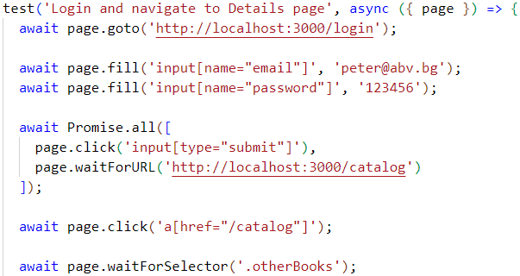

After we have found the first book, we click on its **[Details]** button:



Then, we have to wait for the "**Details**" page to load:



Finally, we have to verify that the correct "**Details"** page has been opened:



#### Verify That Guest User Sees Details Button and Button Works Correctly

Now write a similar test but instead of checking if a logged-in user sees the **[Details]** button, you should check if a guest user sees it.

#### Verify That All Info Is Displayed Correctly

You should write a similar test (it doesn't matter if you use a Guest user or a Logged-In User). This test should check if all of the book information is correct.

#### Verify If Edit and Delete Buttons Are Visible for Creator

Only the creator of a book must be able to see the **[Edit]** and **[Delete]** buttons. Think how to write a test to verify the app logic.

As you can guess, we have to first sign in with a user. User [peter@abv.bg](mailto:peter@abv.bg) is the creator of book "**Outlander**". Check if this user sees the **[Edit]** and **[Delete]** buttons.

#### Verify If Edit and Delete Buttons Are Not Visible for Non-Creator

Only the creator of a book must be able to see the **[Edit]** and **[Delete]** buttons. Think how to write a test to verify the app logic.

As you can guess, we have to first sign in with a user. User [john@abv.bg](mailto:john@abv.bg) is **NOT** the creator of book "**Outlander**". Check if this user sees the **[Edit]** and **[Delete]** buttons.

#### Verify If Like Button Is Not Visible for Creator

Only the non-creator of a book must be able to see the **[Like]** button. Think how to write a test to verify the app logic.

Apply the same logic from the previous two tests.

#### Verify If Like Button Is Visible for Non-Creator

Only the non-creator of a book must be able to see the **[Like]** button. Think how to write a test to verify the app logic.

Apply the same logic from the previous three tests.

### "Logout" Functionality

Let's write some tests to check if the logout functionality works correctly.

#### Verify That the "Logout" Button Is Visible

The logic for this test is similar to the logic for the tests that check whether the "**All Books**" and "**Add Book**" links are visible upon login.

The only difference is that we have to check if we have been directed to the correct page after successful logout:



#### Verify That the "Logout" Button Redirects Correctly

The last test that we should execute is to verify that the **[Logout]** button redirects us to <http://localhost:3000/catalog>.

We should login with the predefined credentials, find the **[Logout]** button and retrieve the URL of the page that we were redirected to:

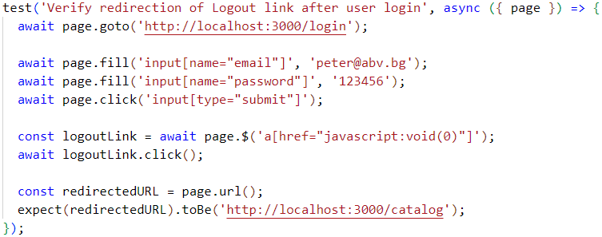

Finally, we can verify that all tests pass using the command, described in the beginning of this document:

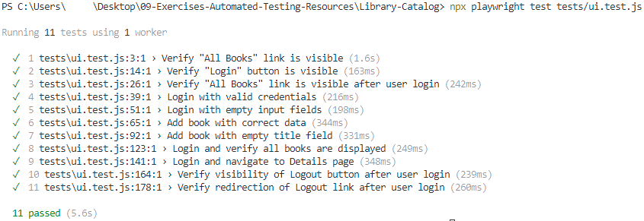

Feel free to try and think of other tests scenarios and cases and try writing tests for them.